EVECHE DE GIKONGORO
CHANCELLERIE
B.P.77 GIKONGORO
RWANDA/AFRIQUE
Tél: (+250)785056454/(+250)727187743
E-mail: evechegik@yahoo.fr (Bureau
kamarampakajc@gmail.com (Privé)

Uruzinduko Mgr Célestin HAKIZIMANA, umwepiskopi wa Diyosezi Gikongoro yagiriye i Kigali (4 Ukwakira 2015)
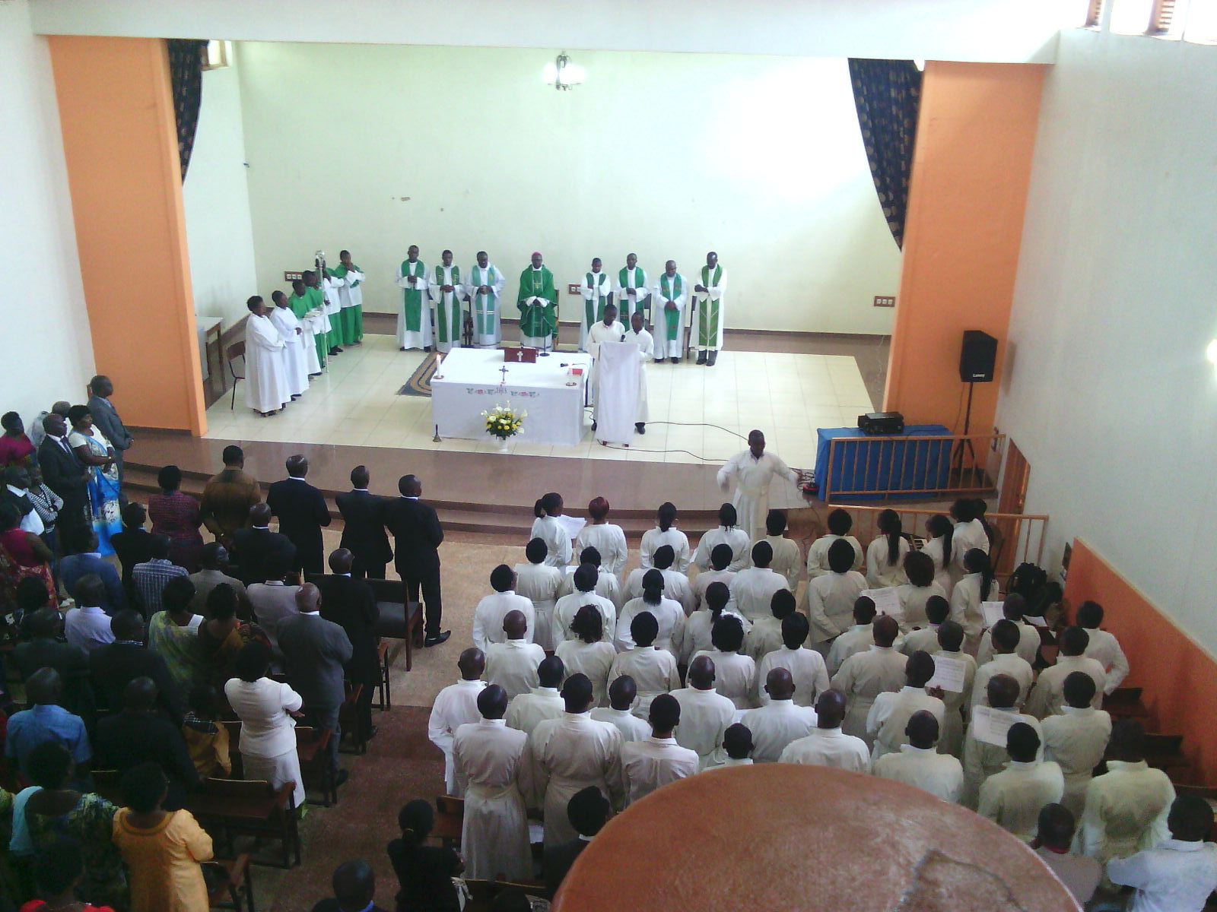
Ku cyumweru tariki ya 4 Ukwakira 2015, Nyiricyubahiro Mgr Célastin HAKIZIMANA, Umwepiskopi wa Diyosezi Gikongoro, aherekejwe na bamwe mu bapadiri n’abakristu ba Diyosezi Gikongoro, yasuye abakristu ba Diyosezi Gikongoro baba i Kigali.

Gahunda y’umunsi yari iteye itya:

10h00-11h30: Igitambo cya Misa
11h30-11h45: Akaruhuko
11H45-12H00: Gufata ibyicaro
12h00-12h15: Kwerekana abashyitsi bavuye muri Diyosezi ya Gikongoro
12h15-12h20: Kwerekana abakristu ba Diyosezi ya Gikongoro n’inshuti zabo batuye i Kigali
12h20-13h30: Inama iyobowe na Mgr Célestin HAKIZIMANA.

Mu gitambo cya Misa cyatangiye i saa yine zuzuye, cyari cyitabiriwe n’abakristu benshi, Mgr Célestin HAKIZIMANA mu nyigisho yatanze yagarutse ku muryango, nk’uko n’amasomo yo kuri icyo cyumweru dusanga mu gitabo cy’Intangiriro 2, 18-24; Ibaruwa yandikiwe Abahebureyi 2, 9-11 n’Ivanjili ya Mariko 10, 2-16, yadufashaga neza kuzirikana ku muryango. Yaragize ati: “Biri amahire, amasomo yo kuri icyi cyumweru yatubwiye ku miryango yacu, (…) ni umwanya duhawe wo kuzirikana icyo ibyanditswe bitagatifu bivuga ku muryango, kugira ngo tuwusigasire, tuwurinde ibyonnyi biwumereye nabi…”.
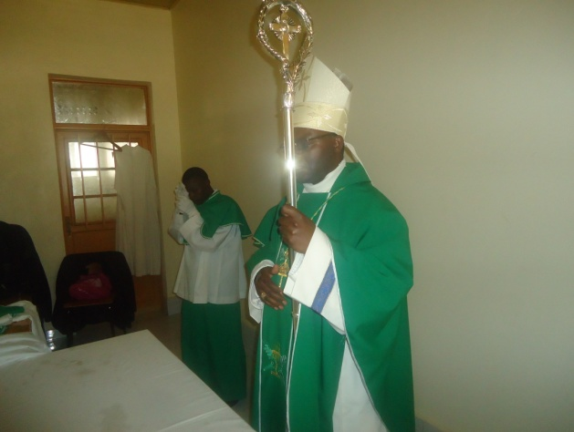
Mu isomo ryo mu gitabo cy’intangiriro twumvise mu isomo rya mbere, aho batubwiye iremwa ry’umugabo n’umugore, yagaragaje ko ariho Kiliziya ishingira yigisha kandi ishimangira uburinganire bw’umugabo n’umugore, ko bose bafite kamere imwe, ko bakwiye icyubahiro kimwe, ko umwe ari umufasha w’undi bakwiranye n’ubwo muri ino minsi hari ho imyumvire igoreka ibintu, ntibifate uko biri, abantu bakagira bati: “umugore ni umufatanyabikorwa w’umugabo, ngo si umugore ni umuntu w’igitsina gore…”.
Mu Ivanjili, mu bisishwa Yezu yari afite imbere ye harimo abafarizayi, bari barekereje ngo bamutege umutego. Ni bwo bamubajije bati: “Umugabo afite uruhushya rwo gusenda umugore we?” baragira ngo barebe niba arwanya itegeko, niyanga ibyo gusenda, azaba yishyize hejuru ya Musa. Nabyemera, azaba ari nta gishya abazaniye, ari ugusubiramo ibyo abandi bigishije. Ivanjili yarangiye bamuzaniye abana baton go abakoreho, ibi bitwigisha ko abana berekana ko umuryango ufunguye, ko umuryango ari uwororoka…
Nyuma y’igitambo cya Misa habayeho kuganira no kungurana ibitekerezo hagamijwe kureba icyafasha abakristu ba Diyosezi Gikongoro gukomera, icyateza imbere Diyosezi Gikongoro. Umwepisikopi mu ijambo rye yabagejejeho gahunda yimirije imbere, imishinga afite, ingorane … yabivuze muri aya magambo:

Nyakubahwa Minisitiri w’Intebe
Nyakubahwa Ministri w’inganda n’ubucuruzi
Nyakubahwa guverneri w’Intara y’amajyepfo
Nyakubahwa Meya w’Akarere ka Nyamagabe
Banyakubahwa mwese buri wese mu rwego rwe
Basaseridoti
Bihayimana
Bakristu bavandimwe,

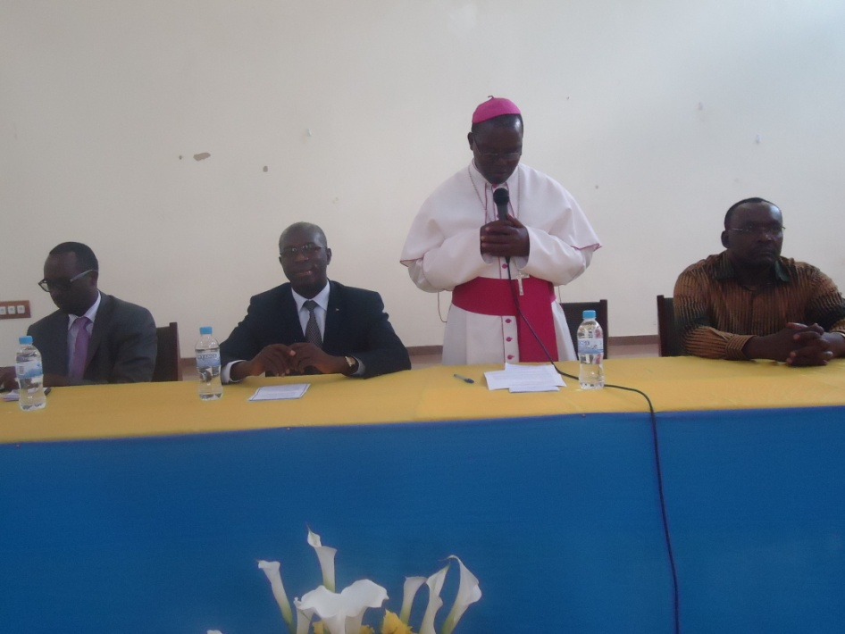
Nyuma y’igitambo cya Misa tumaze gutura dushimira Imana ko tukgihumeka umwuka w’abazima, ndagira ngo nshimire buri wese kuba yitabiriye ubutumire bwa Diyosezi ya Gikongo. Amezi abaye icumi Nyirubutungane Papa Faransisiko antoreye kuyobora Diyosezi gatolika ya Gikongoro, kuko iyo nkuru yasakaye hose ku itariki ya 26 ugushyingo 2014. Amezi abaye umunani mpawe inkoni ya gishumba, hari ku itariki ya 24 Mutarama 2015. Kuri stade ya Nyagisenyi niho byabereye ku mugaragaro, mwese mubyirebera kandi munabyiyumvira kuri Radiyo Mariya. Kutaza i Kigali gushimira abavuka ku Gikongoro batuye i Kigali kwari kuba Mudashima.

Niyo mpamvu ya mbere rero y’uyu munsi, naje kubaganuza ku gitambo cya misa cy’umwepisikopi wanyu, nabazaniye umugisha mushya nahawe na Yezu Kristu, Umusaseridoti Mukuru, naje kubereka ko ya nkoni bampaye, ya mpeta na ya ngofero banyambitse, bikoreshwa neza uko bigomba bitabitswe mu kabati. Naje kubashimira uko mwafashije Diyosezi ya Gikongoro mu minsi mikuru y’ubwepisikopi bwanjye, ibaruwa nabandikiye numvaga idahagije, hagombye uguhura kundi kuko ifuni ibagara ubucuti ari akarenge, cyane cyane ko kuri makumyabiri na kane Mutarama, twerekeje mu mazi magari, ntitubone uko turamukanya ngo tunaganire. Twarabashimye, mwarakoze, tubijeje inkunga y’isengesho kuko numva aricyo twagombye kubarusha. Imana ibasubirije karijana aho mwakuye. Inkunga yanyu ni umubavu uhumura neza. Impamvu ya kabiri, ndagira ngo nshimire bamwe mu banya Gikongoro baba hano muri Kigali bifatanyije n’umuryango wanjye, n’inshuti zanjye z’i Kigali, bakangurira imodoka nshya ya Prado, ndagira ngo kandi munamfashe nshimire Perezida wa Repubulika y’u Rwanda waturihiye imisoro yo muri Gasutamo ingana n’amafaranga y’u Rwanda hafi miliyoni makumyabiri n’eshatu. Impamvu ya gatatu yo guhura kwacu nagira ngo mbabwire uko Diyosezi yanyu kandi yacu ihagaze, n’aho dushaka kuyiganisha kugira ngo mutwungure inama, mudukosore kandi mubinonosore mukurikije ubunararibonye bwanyu.

Diyosezi ya Gikongoro igizwe na Paruwasi 12, n’icyo bita Quasi Paruwasi ya Kitabi, Kiliziya irahari ariko Padiri Mukuru wayo acumbitse mu Mbuga. Mu minsi ya vuba, turateganya gushinga Paruwasi ya Kitabi, Nyarunyinya ariyo Karambi izavuka kuri Cathédrale ya Gikongoro, Masagara izavuka kuri Kaduha, Kizimyamuriro izavuka kuri Bishyiga, Kivu izavuga kuri Muganza. Nyuma gato hazavuka Ruheru kuri Busanze, Mbazi kuri Cyanika, na Kibumbwe kuri Kaduha. Paruwasi zose zifite Abihayimana, keretse Bishyiga, Busanze na Mushubi, Diyosezi irimo gukora ibishoboka byose ngo izo Paruwasi zibone abihayimana bazikoreramo, ndetse nahari umuryango umwe, ube wakwiyongeraho undi nibura. Diyosezi yatangiye uburyo bwo gucunga neza umutungu wayo kandi ku buryo bugezweho, ari umutungo w’amafaranga, umutungo w’abantu n’umutungo w’ibintu. Kubyerekeye amasambu, Diyosezi yashyizeho umupadiri ushinzwe amasambu kugira ngo ayabaruze neza, agarure ayo baduhuguje, akosore ayabarujwe nabi. Hari imishinga ibiri yatangiye gutekerezwaho: i Kizimyamuriro, Diyosezi irashaka kuhashyira umushinga w’ubworozi n’ubuhinzi bw’ibirayi, ndetse no kuhashyira uruganda rwo kubika ibyo birayi no kubibyaza undi musaruro nk’ifu, ifiriti n’ibindi; hari isambuyo mu Ruramba na none dushaka kororeramo no guhingamo ibizatunga Paruwasi na Diyosezi. Kibeho iri ku isonga mu mishanga ya Diyosezi igomba gutezwa imbere. Plan y’umugi wa Kibeho yarakozwe, twayishyikirije ababishinzwe, hategerejwe inama yo kubinonosora, ariko ubu ngubu Diyosezi ifite imishinga ibiri izatangira vuba kandi abagiraneza barimo kugenda baboneka: hari Kiriziya bazajya bashengereramo Ukaristiya Ntagatifu buri gihe na Kiriziya bazajya batangiramo isakramentu rya penetensiya, abagiraneza bo muri Polonye bazafasha.

Hari rero na Kiriziya nini, “ihuriro ry’abatatanye”, izajyamo abantu ibihumbi 15 bicaye, nyuma tukazasaba Vatikani ko bayita Basilika. Hari abanyamerika bashaka kuzabidufashamo. Umushinga wa nyuma nasozerezaho, nyamara ari nawo wa mbere n’i Seminari ntoya ya Diyosezi ya Gikongoro, izubakwa mu Cyanika, nkaba nifuza ko umwaka wa mbere watangira mu kwezi kwa mbere 2017. Ikibanza cyarabonetse, ubu harimo gukorwa devis, maze tugatangira gushakisha amafaranga. Imishinga dufite siyo kubaka gusa amazu, kuko amazu adafite fondasiyo mu mutima aba yubatse ku musenyi. Kubera genocide yakorewe abatutsi yashegeshe Paruwasi eshanu: Gikongoro, Cyanika, Muganza, Kaduha na Kibeho, turateganya gushaka ikenurabushyo rijyanye n’imiterere yaho hantu, maze tugafatanya na Communauté ya Emmanuel, tukareba ko twabasubize icyizere cyo kubaho. Amashuri tuzayitaho by’umwihariko kuko ubona abana batagifite gikurikira, cyangwa se n’ababakurikirana, ugasanga barabigisha ibintu bidahuye n’imyemerere ya Kiriziya Gatolika. Umuryango nawo tuzawitaho, twigisha ubusugire bw’ingo, twigisha n’abantu kuboneza urubyaro bakoresheje uburyo bwa kamere, kuva kuri diyosezi, kugeza mu Miryango Remezo, no kuva ku kigo nderabuzima kugera ku bajyanama b’ubuzima muri buri Mudugudu.

Nyuma yo kubagezaho gahunda ya Diyosezi, imishinga, imbogamizi, abakristu bahawe akanya bagira icyo bavuga:

Abayobozi mu nzego bwite za Leta bari aho (twavuga nka Bwana MUREKEZI Anastase, Ministre w’intere; Bwana KANIMBA Francois, Minisitri w’Inganda n’Ubucuruzi wari kumwe na Madamu we; Bwana MUNYANTWALI Alphonse, Guverneri w’Intara y’Amajyepho; Bwana MUGISHA Philbert, Meya W’akarere Ka Nyamagabe; hari kandi na Bwana Senateri Garcan; Bwana Célestin NTIVUGURUZWA, Umunyamabanga uhoraho wa Ministeri y’Uburezi; Bwana Clement MUSANGABATWARE, Umuvunyi Mukuru wungirije; Abayobozi b’akarere bungirije bashinzwe imari n’ubukungu mu turere twa Nyamagabe na Huye; n’abandi bari munzego zindi z’ubuyobozi bwa Leta) baranzwe no gushima icyo gikorwa cyabaye.

Bwana MUNYANTWALI Alphonse, Guverneri w’Intara y’amajyepfo, yaranzwe no gushima icyo gikorwa cyabaye kigahuza abanyagikongoro batuye i Kigali, mu magambo ye, yaragize ati: “iki ni ikimenyetso cy’umushumba mwiza, umenya n’intama zirisha ahandi, ni igikorwa cy’agaciro ahaye abo ayobora”, asoza yizeza umwepiskopi ubufatanye mu iterambere rya Diyosezi ndetse no mu mishinga yaramaze kubagezaho.

Mu kuganira no kungurana ibitekerezo, abafashe ijambo bose, ntawarangizaga adasabye ko hafungurwa konti yajya inyuzwaho amafranga yo kunganira Diyosezi mu mishinga myinshi ifite kandi bakayibamenyesha.

Basabye kandi ko hanatekerezwa ku gikorwa cyabyarira inyungu Diyosezi bityo kikajya cyunganira Diyosezi mu gusohoza neza ubutumwa ifite bwo kugeza kuri bose Yezu Kristu, abandi bati hakwiye kujyaho équipe consultative des experts bagaragaza ko biteguye kuyijyamo no gutanga umusanzu wabo ngo ibyo bifuza byose bigerweho, aha Bwana Francois KANIMBA yemeye ku mugaragaro ko yiteguye gutanga ubufasha bw’inama n’ibitekerezo muri iyo équipe igihe izaba yagiyeho nk’uko nahandi bamwiyambaza kandi akabikora.

Umushinga wo kubaka i Seminari nto mu Cyanika wishimiwe na bose, abakristu baba i Kigali bagaragaza ko biteguye gutanga umusanzu ngo utangire gushirwa mu bikorwa, basaba gufungurirwa Konti yanyuzwaho amafranga yo kubaka Seminari kandi ibyo bigakorwa vuba. Ministre KANIMBA François mu ijambo rye yashimye umushinga wo kubaka i Seminari yihariye ya Diyosezi ya Gikongoro mu cyanika, ndetse yemera no kuzawushyigikira atanga umuzanzu wo kuyubaka, yaragize ati: “abana banjye bose bize Seminari, nakurikirana aho bakoreye ikizamini, nkumva ari mu Cyanika, ariko bajya kwiga bakajya ahandi hatari ku Gikongoro(...) umusanzu wanjye ndawemeye”

Ku birebana n’umushinga w’uruganda ruzajya rutunganya ibirayi muri Paruwasi ya Bishyiga i Kizimyamuriro, Ministre Fançois KANIMBA, yasabye umwepiskopi ko bazashyikiriza umushinga uteguye neza ministeri ayoboye bagafatanya kuwushyira mu bikorwa.

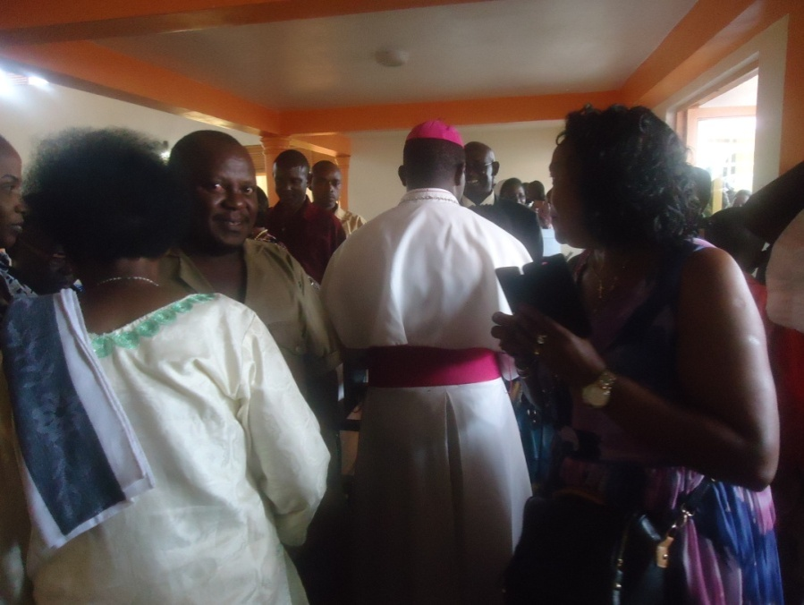
Ibindi byavuzwe mu biganiro ni umusaraba wahoze ku musozi wa Nyagane wafashaga akakristu ba Paruwasi ya Kaduha ubu utagihari, basaba ko bishobotse wasubirayo kuko wafashaga benshi mu isengesho; abanyabuzanze baba i Kigali bagaragaje ko bafite ubushake bwo kubabaka Kiliziya ifatika i Nyarusange yazaba zantarari mu minsi iri imbere.

Mu gusoza Bwana MUREKEZI Anastase, Ministiri w’intebe, yashimye gahunda Diyosezi ya Gikongoro ifite n’uburyo yatekereje kuyigeza no ku ntama za Diyosezi zituye i Kigali, ashima uburyo uburezi, umuryango n’imibereho myiza y’abaturage byahawe umwanya w’ibanze. Asoza yizeza umushumba wa Diyosezi Gikongoro ubufasha. Uruzinduko rwashijwe n’ubusabane.

Gikongoro ku wa 6 Ukwakira 2015

Padiri Jean Claude KAMARAMPAKA
Umunyamabanga wa Diyosezi Gikongoro

